**Контроль версий углублённо (GIT). Обучение в записи**

**Урок 2. Семинар: Работа с удалёнными репозиториями**



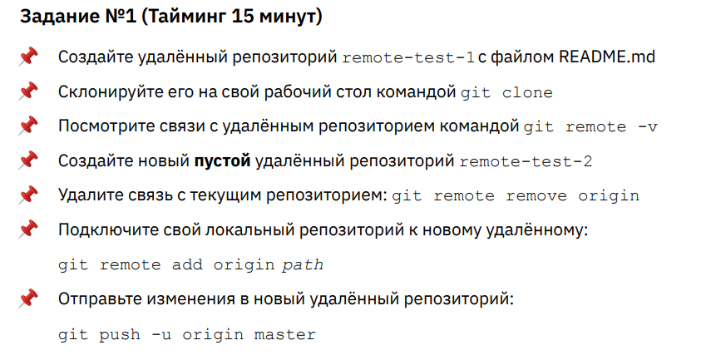

**Ход выполнения задания 1.**

*user@DESKTOP-929P2AG MINGW64 ~*

*$ cd Desktop/*

*user@DESKTOP-929P2AG MINGW64 ~/Desktop*

*$ pwd*

*/c/Users/user/Desktop*

*user@DESKTOP-929P2AG MINGW64 ~/Desktop*

*$ git clone git@github.com:olgashenkel/remote-test-1.git*

*Cloning into 'remote-test-1'...*

*remote: Enumerating objects: 3, done.*

*remote: Counting objects: 100% (3/3), done.*

*remote: Total 3 (delta 0), reused 0 (delta 0), pack-reused 0 (from 0)*

*Receiving objects: 100% (3/3), done.*

*user@DESKTOP-929P2AG MINGW64 ~/Desktop*

*$ cd remote-test-1/*

*user@DESKTOP-929P2AG MINGW64 ~/Desktop/remote-test-1 (main)*

*$ git remote -v*

*origin git@github.com:olgashenkel/remote-test-1.git (fetch)*

*origin git@github.com:olgashenkel/remote-test-1.git (push)*

*user@DESKTOP-929P2AG MINGW64 ~/Desktop/remote-test-1 (main)*

*$ git remote remove origin*

*user@DESKTOP-929P2AG MINGW64 ~/Desktop/remote-test-1 (main)*

*$ git remote -v*

*user@DESKTOP-929P2AG MINGW64 ~/Desktop/remote-test-1 (main)*

*$ git remote add origin git@github.com:olgashenkel/remote-test-2.git*

*user@DESKTOP-929P2AG MINGW64 ~/Desktop/remote-test-1 (main)*

*$ git push -u origin main*

*Enumerating objects: 3, done.*

*Counting objects: 100% (3/3), done.*

*Writing objects: 100% (3/3), 889 bytes | 889.00 KiB/s, done.*

*Total 3 (delta 0), reused 3 (delta 0), pack-reused 0*

*To github.com:olgashenkel/remote-test-2.git*

*\* [new branch] main -> main*

*branch 'main' set up to track 'origin/main'.*

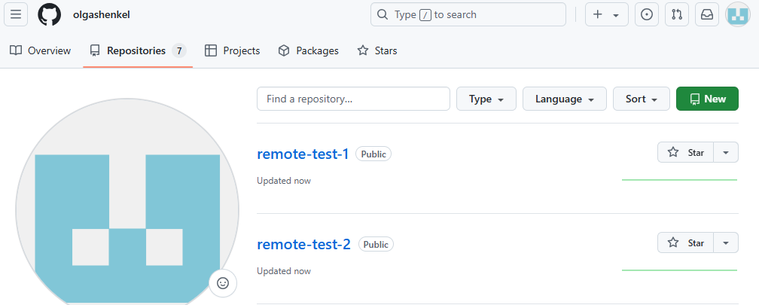

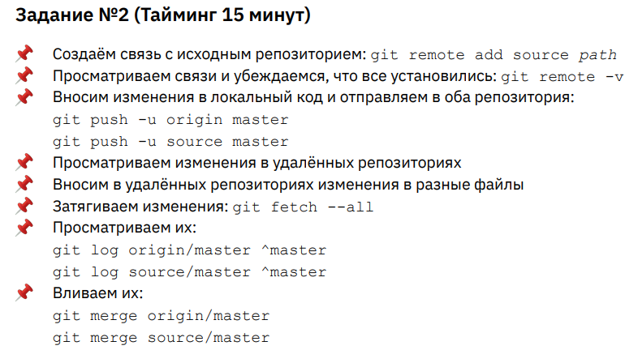

**Ход выполнения задания 2.**

*user@DESKTOP-929P2AG MINGW64 ~/Desktop/remote-test-1 (main)*

*$ git remote add source git@github.com:olgashenkel/remote-test-1.git*

*user@DESKTOP-929P2AG MINGW64 ~/Desktop/remote-test-1 (main)*

*$ git remote -v*

*origin git@github.com:olgashenkel/remote-test-2.git (fetch)*

*origin git@github.com:olgashenkel/remote-test-2.git (push)*

*source git@github.com:olgashenkel/remote-test-1.git (fetch)*

*source git@github.com:olgashenkel/remote-test-1.git (push)*

*user@DESKTOP-929P2AG MINGW64 ~/Desktop/remote-test-1 (main)*

*$ git status*

*On branch main*

*Your branch is up to date with 'origin/main'.*

*Changes not staged for commit:*

*(use "git add <file>..." to update what will be committed)*

*(use "git restore <file>..." to discard changes in working directory)*

*modified: README.md*

*no changes added to commit (use "git add" and/or "git commit -a")*

*user@DESKTOP-929P2AG MINGW64 ~/Desktop/remote-test-1 (main)*

*$ git add .*

*user@DESKTOP-929P2AG MINGW64 ~/Desktop/remote-test-1 (main)*

*$ git commit -m "update README.md"*

*[main e786c05] update README.md*

*1 file changed, 2 insertions(+), 1 deletion(-)*

*user@DESKTOP-929P2AG MINGW64 ~/Desktop/remote-test-1 (main)*

*$ git status*

*On branch main*

*Your branch is ahead of 'origin/main' by 1 commit.*

*(use "git push" to publish your local commits)*

*nothing to commit, working tree clean*

*user@DESKTOP-929P2AG MINGW64 ~/Desktop/remote-test-1 (main)*

*$ git push -u origin main*

*Enumerating objects: 5, done.*

*Counting objects: 100% (5/5), done.*

*Delta compression using up to 20 threads*

*Compressing objects: 100% (2/2), done.*

*Writing objects: 100% (3/3), 347 bytes | 347.00 KiB/s, done.*

*Total 3 (delta 0), reused 0 (delta 0), pack-reused 0*

*To github.com:olgashenkel/remote-test-2.git*

*efa0c36..e786c05 main -> main*

*branch 'main' set up to track 'origin/main'.*

*user@DESKTOP-929P2AG MINGW64 ~/Desktop/remote-test-1 (main)*

*$ git push -u source main*

*Enumerating objects: 5, done.*

*Counting objects: 100% (5/5), done.*

*Delta compression using up to 20 threads*

*Compressing objects: 100% (2/2), done.*

*Writing objects: 100% (3/3), 347 bytes | 347.00 KiB/s, done.*

*Total 3 (delta 0), reused 0 (delta 0), pack-reused 0*

*To github.com:olgashenkel/remote-test-1.git*

*efa0c36..e786c05 main -> main*

*branch 'main' set up to track 'source/main'.*

*user@DESKTOP-929P2AG MINGW64 ~/Desktop/remote-test-1 (main)*

*$ git status*

*On branch main*

*Your branch is up to date with 'source/main'.*

*nothing to commit, working tree clean*

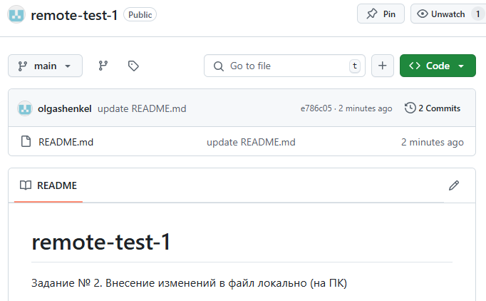 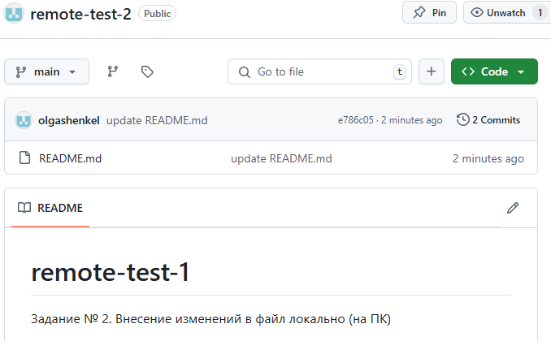

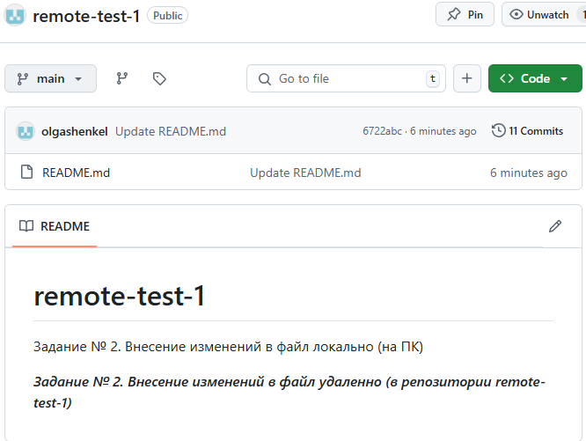

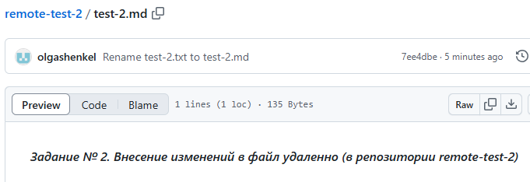

*user@DESKTOP-929P2AG MINGW64 ~/Desktop/remote-test-1 (main)*

*$ git log source/main ^main*

*user@DESKTOP-929P2AG MINGW64 ~/Desktop/remote-test-1 (main)*

*$ git fetch --all*

*Fetching origin*

*remote: Enumerating objects: 8, done.*

*remote: Counting objects: 100% (8/8), done.*

*remote: Compressing objects: 100% (7/7), done.*

*remote: Total 7 (delta 0), reused 0 (delta 0), pack-reused 0 (from 0)*

*Unpacking objects: 100% (7/7), 2.80 KiB | 124.00 KiB/s, done.*

*From github.com:olgashenkel/remote-test-2*

*669862c..7ee4dbe main -> origin/main*

*Fetching source*

*remote: Enumerating objects: 8, done.*

*remote: Counting objects: 100% (8/8), done.*

*remote: Compressing objects: 100% (4/4), done.*

*Unpacking objects: 100% (6/6), 1.80 KiB | 80.00 KiB/s, done.*

*remote: Total 6 (delta 2), reused 0 (delta 0), pack-reused 0 (from 0)*

*From github.com:olgashenkel/remote-test-1*

*fcda8b8..6722abc main -> source/main*

*user@DESKTOP-929P2AG MINGW64 ~/Desktop/remote-test-1 (main)*

*$ git log origin/main ^main*

*commit 7ee4dbe2ef3e36f078ce233a9a9bfbf66e8a4e56 (origin/main)*

*Author: olgashenkel <158843723+olgashenkel@users.noreply.github.com>*

*Date: Sun Jan 5 21:55:55 2025 +0200*

*Rename test-2.txt to test-2.md*

*commit 2dcd21d8a39c3d876f3364218e8a3b91d427e4e4*

*Author: olgashenkel <158843723+olgashenkel@users.noreply.github.com>*

*Date: Sun Jan 5 21:55:35 2025 +0200*

*Rename test-2 to test-2.txt*

*commit 9024f00f2f8fdfd257cc774a992488aafbf15ad3*

*Author: olgashenkel <158843723+olgashenkel@users.noreply.github.com>*

*Date: Sun Jan 5 21:54:59 2025 +0200*

*Update test-2*

*commit 669862c134ef190dc6c294c2c76afcad3db708ab*

*Author: olgashenkel <158843723+olgashenkel@users.noreply.github.com>*

*Date: Sun Jan 5 11:05:35 2025 +0200*

*Create test-2*

*user@DESKTOP-929P2AG MINGW64 ~/Desktop/remote-test-1 (main)*

*$ git log source/main ^main*

*commit 6722abc4628bb87d94bf3298d92d12e5d77da6db (source/main)*

*Author: olgashenkel <158843723+olgashenkel@users.noreply.github.com>*

*Date: Sun Jan 5 21:54:27 2025 +0200*

*Update README.md*

*commit 30ce0233049ce803f67eae6fe4d20ee4f2d03493*

*Author: olgashenkel <158843723+olgashenkel@users.noreply.github.com>*

*Date: Sun Jan 5 21:54:08 2025 +0200*

*Update README.md*

*user@DESKTOP-929P2AG MINGW64 ~/Desktop/remote-test-1 (main)*

*$ git merge origin/main*

*Merge made by the 'ort' strategy.*

*test-2.md | 1 +*

*1 file changed, 1 insertion(+)*

*create mode 100644 test-2.md*

*user@DESKTOP-929P2AG MINGW64 ~/Desktop/remote-test-1 (main)*

*$ git merge source/main*

*Merge made by the 'ort' strategy.*

*README.md | 3 ++-*

*1 file changed, 2 insertions(+), 1 deletion(-)*

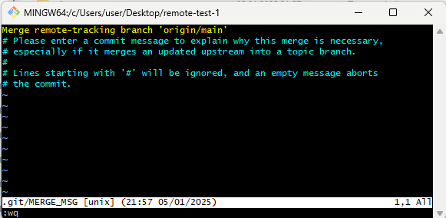 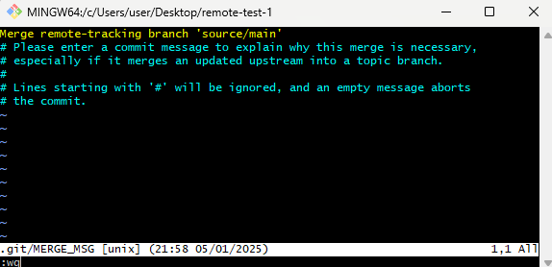

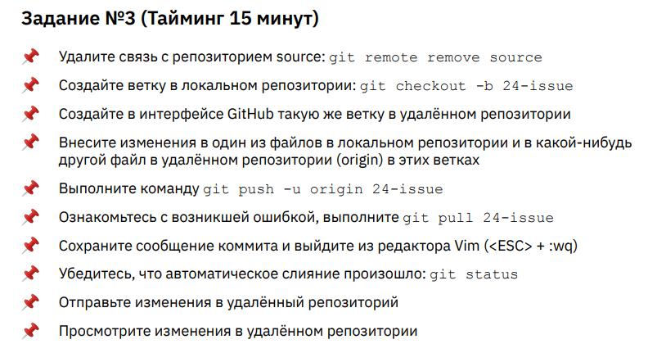

**Ход выполнения задания 3.**

*user@DESKTOP-929P2AG MINGW64 ~/Desktop/remote-test-1 (main)*

*$ git remote remove source*

*user@DESKTOP-929P2AG MINGW64 ~/Desktop/remote-test-1 (main)*

*$ git remote -v*

*origin git@github.com:olgashenkel/remote-test-2.git (fetch)*

*origin git@github.com:olgashenkel/remote-test-2.git (push)*

*user@DESKTOP-929P2AG MINGW64 ~/Desktop/remote-test-1 (main)*

*$ git checkout -b 24-issue*

*Switched to a new branch '24-issue'*

*user@DESKTOP-929P2AG MINGW64 ~/Desktop/remote-test-1 (24-issue)*

*$ git branch*

*\* 24-issue*

*main*

*user@DESKTOP-929P2AG MINGW64 ~/Desktop/remote-test-1 (24-issue)*

*$ git status*

*On branch 24-issue*

*Changes not staged for commit:*

*(use "git add <file>..." to update what will be committed)*

*(use "git restore <file>..." to discard changes in working directory)*

*modified: README.md*

*no changes added to commit (use "git add" and/or "git commit -a")*

*user@DESKTOP-929P2AG MINGW64 ~/Desktop/remote-test-1 (24-issue)*

*$ git add .*

*user@DESKTOP-929P2AG MINGW64 ~/Desktop/remote-test-1 (24-issue)*

*$ git commit -m "update RADME.md"*

*[24-issue 79cbb52] update RADME.md*

*1 file changed, 2 insertions(+)*

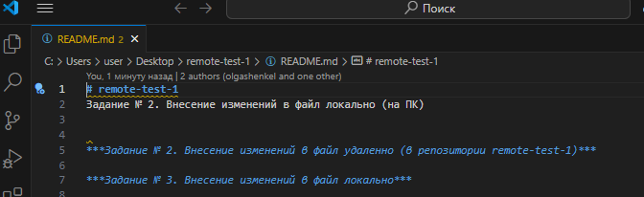

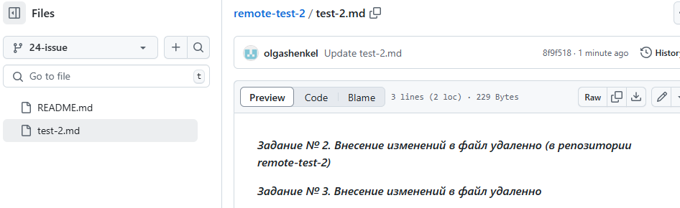

*user@DESKTOP-929P2AG MINGW64 ~/Desktop/remote-test-1 (24-issue)*

*$ git push -u origin 24-issue*

*To github.com:olgashenkel/remote-test-2.git*

*! [rejected] 24-issue -> 24-issue (fetch first)*

*error: failed to push some refs to 'github.com:olgashenkel/remote-test-2.git'*

*hint: Updates were rejected because the remote contains work that you do not*

*hint: have locally. This is usually caused by another repository pushing to*

*hint: the same ref. If you want to integrate the remote changes, use*

*hint: 'git pull' before pushing again.*

*hint: See the 'Note about fast-forwards' in 'git push --help' for details.*

*user@DESKTOP-929P2AG MINGW64*

*~/Desktop/remote-test-1 (24-issue)*

*$ git pull origin 24-issue*

*user@DESKTOP-929P2AG MINGW64 ~/Desktop/remote-test-1 (24-issue)*

*$ git status*

*Merge made by the 'ort' strategy.*

*test-2.md | 2 ++*

*1 file changed, 2 insertions(+)*

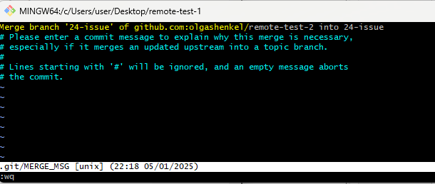

*user@DESKTOP-929P2AG MINGW64 ~/Desktop/remote-test-1 (24-issue)*

*$ git push origin 24-issue*

*Enumerating objects: 37, done.*

*Counting objects: 100% (35/35), done.*

*Delta compression using up to 20 threads*

*Compressing objects: 100% (23/23), done.*

*Writing objects: 100% (29/29), 7.54 KiB | 7.54 MiB/s, done.*

*Total 29 (delta 6), reused 0 (delta 0), pack-reused 0*

*remote: Resolving deltas: 100% (6/6), done.*

*To github.com:olgashenkel/remote-test-2.git*

*8f9f518..46941f8 24-issue -> 24-issue*

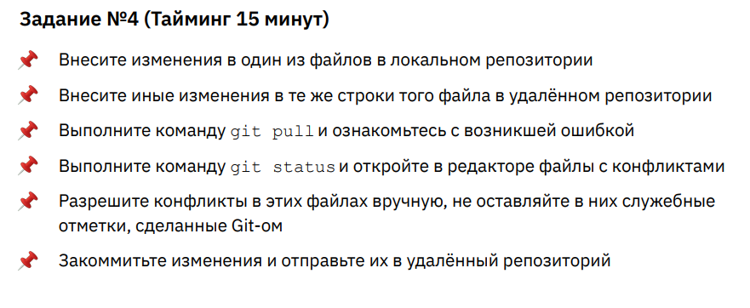

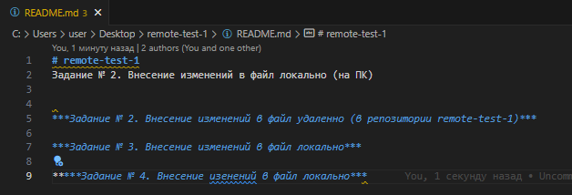

*user@DESKTOP-929P2AG MINGW64 ~/Desktop/remote-test-1 (24-issue)*

*$ git status*

*On branch 24-issue*

*Changes not staged for commit:*

*(use "git add <file>..." to update what will be committed)*

*(use "git restore <file>..." to discard changes in working directory)*

*modified: README.md*

*no changes added to commit (use "git add" and/or "git commit -a")*

*user@DESKTOP-929P2AG MINGW64 ~/Desktop/remote-test-1 (24-issue)*

*$ git add .*

*user@DESKTOP-929P2AG MINGW64 ~/Desktop/remote-test-1 (24-issue)*

*$ git commit -m "update README.md"*

*[24-issue 3751506] update README.md*

*1 file changed, 1 insertion(+), 1 deletion(-)*

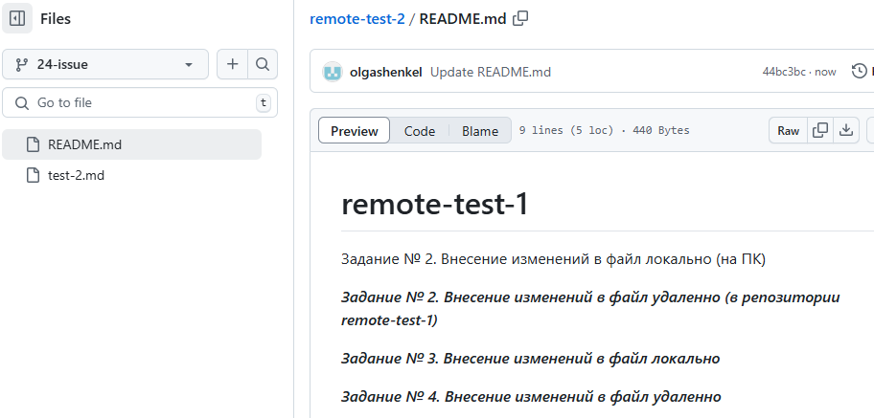

*user@DESKTOP-929P2AG MINGW64 ~/Desktop/remote-test-1 (24-issue)*

*$ git pull origin 24-issue*

*From github.com:olgashenkel/remote-test-2*

*\* branch 24-issue -> FETCH_HEAD*

*Auto-merging README.md*

*CONFLICT (content): Merge conflict in README.md*

*Automatic merge failed; fix conflicts and then commit the result.*

*user@DESKTOP-929P2AG MINGW64 ~/Desktop/remote-test-1 (24-issue|MERGING)*

*$ git status*

*On branch 24-issue*

*You have unmerged paths.*

*(fix conflicts and run "git commit")*

*(use "git merge --abort" to abort the merge)*

*Unmerged paths:*

*(use "git add <file>..." to mark resolution)*

*both modified: README.md*

*no changes added to commit (use "git add" and/or "git commit -a")*

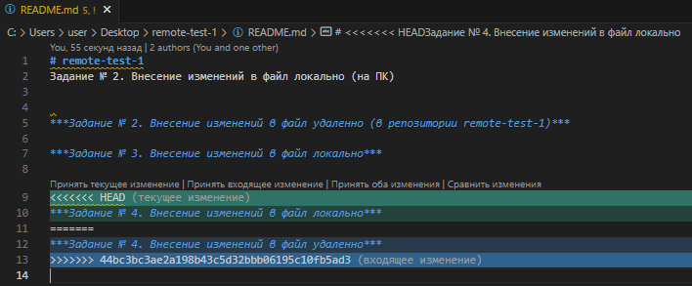

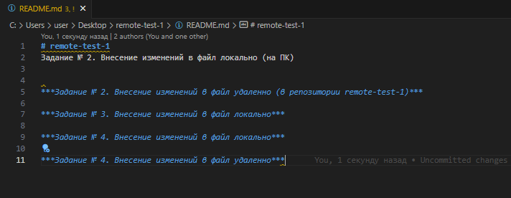

*user@DESKTOP-929P2AG MINGW64 ~/Desktop/remote-test-1 (24-issue|MERGING)*

*$ git status*

*On branch 24-issue*

*You have unmerged paths.*

*(fix conflicts and run "git commit")*

*(use "git merge --abort" to abort the merge)*

*Unmerged paths:*

*(use "git add <file>..." to mark resolution)*

*both modified: README.md*

*no changes added to commit (use "git add" and/or "git commit -a")*

*user@DESKTOP-929P2AG MINGW64 ~/Desktop/remote-test-1 (24-issue|MERGING)*

*$ git add .*

*user@DESKTOP-929P2AG MINGW64 ~/Desktop/remote-test-1 (24-issue|MERGING)*

*$ git commit -m "update README.md"*

*[24-issue f87e73c] update README.md*

*user@DESKTOP-929P2AG MINGW64 ~/Desktop/remote-test-1 (24-issue)*

*$ git push origin 24-issue*

*Enumerating objects: 13, done.*

*Counting objects: 100% (13/13), done.*

*Delta compression using up to 20 threads*

*Compressing objects: 100% (9/9), done.*

*Writing objects: 100% (9/9), 897 bytes | 897.00 KiB/s, done.*

*Total 9 (delta 3), reused 0 (delta 0), pack-reused 0*

*remote: Resolving deltas: 100% (3/3), completed with 1 local object.*

*To github.com:olgashenkel/remote-test-2.git*

*44bc3bc..f87e73c 24-issue -> 24-issue*

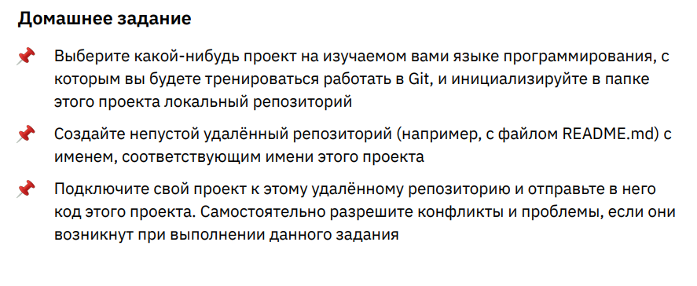

***Ссылка на репозиторий GitHub:***

[***https://github.com/olgashenkel/GeekBrains-specialization-ELECTIVES***](https://github.com/olgashenkel/GeekBrains-specialization-ELECTIVES)